

When we are out and about in the community, one of the most common things we hear Barking and Dagenham residents say is how difficult and time consuming it has become to get a face-to-face GP appointment. It is evident that Covid-19 pandemic has exacerbated access problems in general practice. However, some residents have expressed that getting a face-to-face appointment with their GP is as easy as it was pre-Covid.

There is not a single component that is responsible for this access concern. residents of Barking and Dagenham told us that:

“The system is not fit for purpose; I call them, and I am told I am number 33 in the queue. 9 times out of 10 I cannot get an appointment.”

“I cannot get an appointment despite ringing them constantly. Eventually they booked a telephone appointment but changed the date without telling me, which caused me to miss it.”

“My GP surgery is very good; I always get an appointment. If I rang them today, I would be getting an appointment in 2 days’ time.”

“Pandemic is over, but my doctor only offers telephone calls, no face-to-face appointments.”

“I cannot get a face-to-face appointment before having e-consult. My parents are elderly, and they don’t know how to use it, this system is discriminating people who cannot use technology”.

“I had difficulty getting an appointment, call at 8am then I went in person and then they gave me an appointment.”

Do these issues sound familiar? We have prepared a helpful guide on steps to take in order to be seen face to face by your GP. Please see information below:

|  |  |
| --- | --- |
| **Service/organization** | **Contact details and links** |
| You should always try to contact your GP surgery using their contact details that are published on their website. If you are experiencing difficulties booking appointments over the phone, there are some applications that can be downloaded on your smartphone – they allow you to book appointments online. Links are provided here → | [**NHS app**](https://play.google.com/store/apps/details?id=com.nhs.online.nhsonline)  [**My GP app**](https://play.google.com/store/apps/details?id=net.iplato.mygp&hl=en_GB&gl=US&pli=1)  [**Patient access app**](https://play.google.com/store/apps/details?id=uk.co.patient.patientaccess&hl=en_GB&gl=US&pli=1)  More information on online services can be found [here.](https://www.nhs.uk/nhs-services/gps/using-online-services/) |
| **Use E-consults**. These are where you fill out a form online and are asked a series of questions based on what the issue is. A GP should read it within two to three days and can respond with an answer, call you or arrange a face-to-face consultation if necessary. E-consults allow you to upload pictures of rashes or moles or other issues they think need to be looked at. | The online form will be on your GP surgery`s website: |
| If you live in Barking and Dagenham, Havering or Redbridge, you can book urgent face to face appointments by calling the **GP hubs** booking hotline (open from 8am-8pm) | 020 3770 1888 |
| If you have an urgent medical issue and you're not sure what to do, call 111 or visit NHS 111 online. **NHS 111** is available 24 hours a day, seven days a week. A trained adviser can give you advice or connect you to a nurse, doctor, pharmacist, paramedic, or dentist. | 111  https://111.nhs.uk/ |
|  |  |
| Use your **pharmacist**. They are healthcare experts, and pharmacists train for five years. In addition to giving out medicines, they are trained in managing minor illnesses and providing health and wellbeing advice. Pharmacists are often worth consulting — and if they can’t help you, they’ll let you know straight away so you can make an appointment with a doctor. | You can find your nearest pharmacy and it`s contact details by using this online search tool:  <https://www.nhs.uk/service-search/pharmacy/find-a-pharmacy> |

Healthwatch Barking and Dagenham provide confidential support and free information to help you understand your options and get the help you need regarding health and social care. Please contact us by telephone **tel:08002985331**, or email **info@healthwatchbarkinganddagenham.co.uk**

Healthwatch Barking and Dagenham

Lifeline House

25 Neville Road

Dagenham, Essex RM8 3QS

https://www.healthwatchbarkinganddagenham.co.uk/

t: tel:08002985331

e: info@healthwatchbarkinganddagenham.co.uk

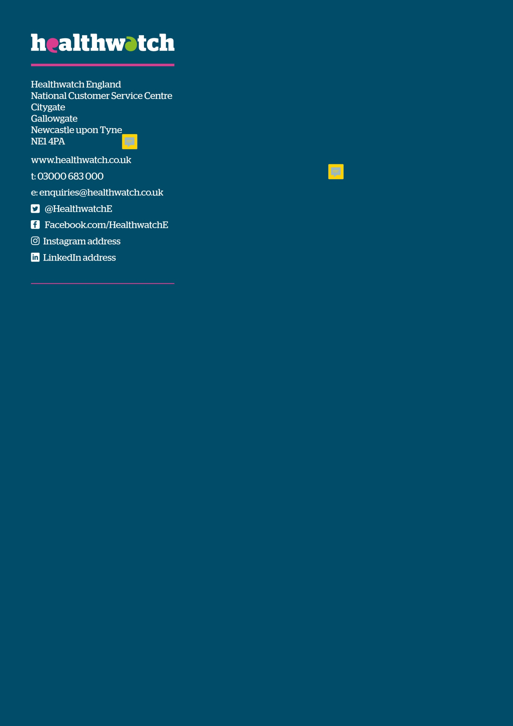 @HealthwatchBD

 https://www.facebook.com/healthwatch.bd